Travel Information
The closest town to both the church and the reception venue is Barnard Castle.

Travel by Train
The nearest station is Darlington, about 15 miles from Barnard Castle (approximately £25 taxi journey). GNER trains run to Darlington direct from London King's Cross, and the journey time is usually around 2 hours and 45 minutes. Station Taxi 01325 484 888.
www.gner.co.uk

Travelling by plane
The nearest airport is Durham Tees Valley, around 30 miles from Barnard Castle. bmi runs flights from London Heathrow, and bmi baby runs flights from London Gatwick to Durham Tees Valley. The Airport Taxis are as reasonable as any (about £30 to Hotel).
www.durhamteesvalleyairport.com
www.flybmi.com
www.bmibaby.com

Taxis local to Hotel
Cat's Cabs - 01833 630111
Hodgsons Private Hire - 01833 637641

Coach to and from the Church
A coach is available for guests staying at the Morritt Arms Hotel for travel from the hotel to the church, and back to the hotel for the reception. The coach leaves the Morritt at 2:15pm.

Gift List Information

Honeymoon Experiences
For our honeymoon we'll be spending a week in New York followed by a week in London. Our website, www.mrandmrsyoung.co.uk, details a number of experiences that we would love to have over the fortnight, and gives details of how to purchase these experiences for us.

John Lewis Gift List
As an alternative to buying honeymoon experiences, we have created a gift list at John Lewis. This can be accessed by visiting www.johnlewisgiftlist.com and entering our unique gift list number 225046. The gifts will be available for purchase from the 17th November 2006.

St Andrew’s Church, Winston

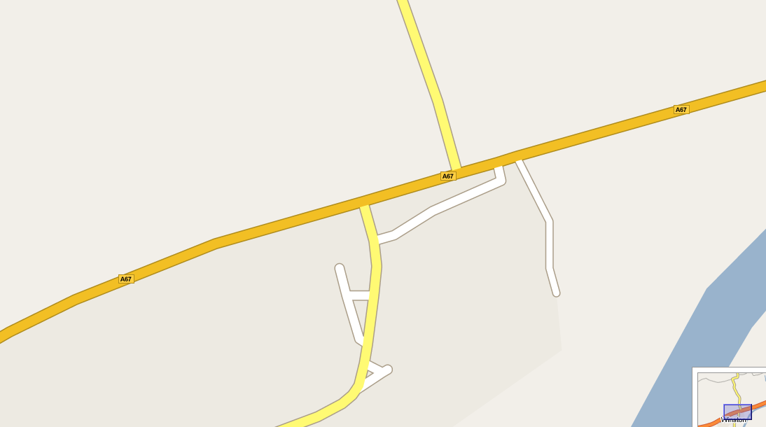
A67
P
P
St Andrew’s Church, Winston, DL2 3RL
The Bridgewater Arms Pub, serving lunch until 2pm and drinks until 3pm
Winston Village Hall – toilet facilities available
Area available for parking, please follow signs
Route to Morritt Arms Hotel and Barnard Castle
Route to Darlington and A1

The Morritt Arms Hotel, Greta Bridge

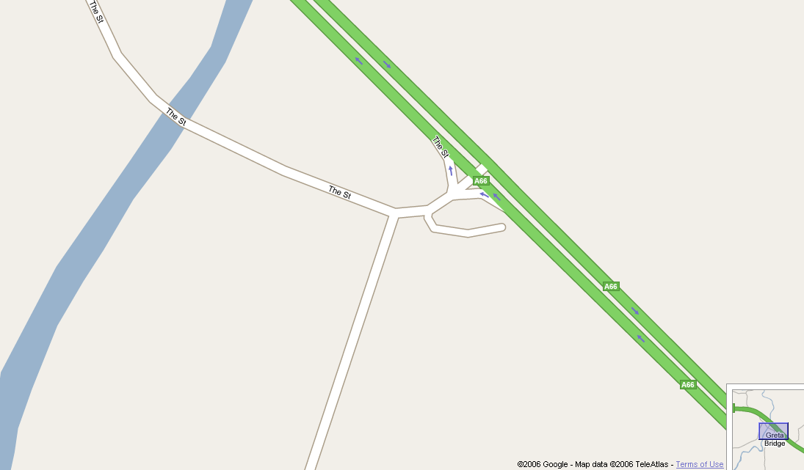
A66
The Morritt Arms Hotel,
Greta Bridge,
Co. Durham,
DL12 9SE

Follow the brown signpost from the A66
Route to Winston
and Scotch Corner (A1)
Route to Barnard Castle

Suggested route between Church and Reception Venue
First turn on the left after Winston, signposted to Whorlton
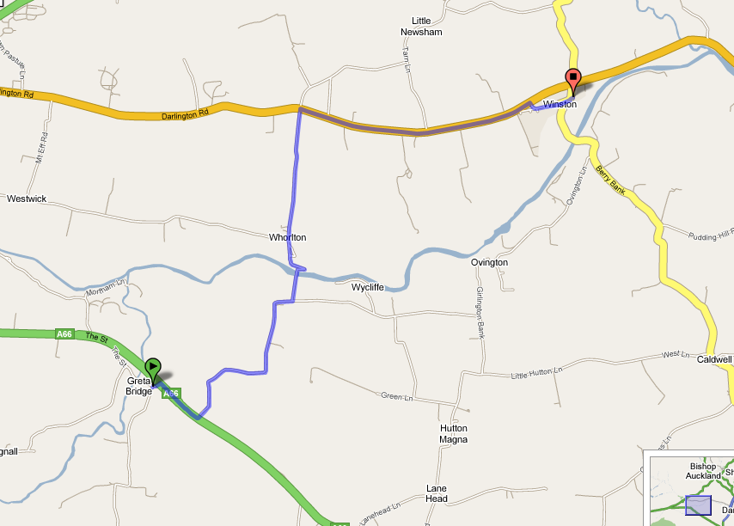
St Andrew’s Church, Winston, DL2 3RL
The Morritt Arms Hotel,
Greta Bridge,
Co. Durham,
DL12 9SE

Further Information
For further information, please visit our website at www.mrandmrsyoung.co.uk.

